**Political juggernauts: A Quantitative analysis of candidates in the 2019 Lok sabha elections**

1. **Introduction**

* 1. **Overview**

  Policy Implications : Depending on the projects goals it might discus the policy implications of the findings .For instance if the analysis reveals a lack of gender diversity among canfidates , it could purpose policy recommendations to address this issue.

* 1. **Purpose**

 Public awareness : The projects finding can rise public awareness about the state of politics in India foresting a more informed and engaged citizenry.

Long -Term impact :

             By understanding the candidate landscape in the 2019 lok sabha elections , the project may have implications for future elections , encouraging changes in candidate selection and electroal stategies

**2.Problem Definition & Design Thinking**

Problem Understanding, also known as Problem Definition or Problem Identification, is the initial and critical phase of any data analysis or problem-solving process. It involves gaining a clear and comprehensive understanding of the problem at hand, its context, scope, and objectives.

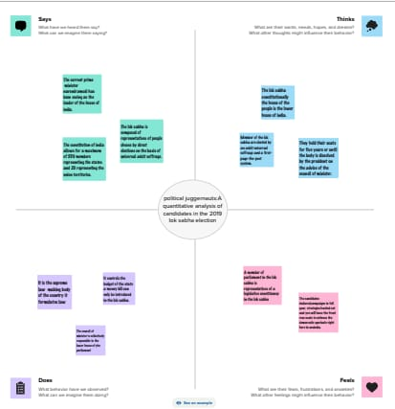**Emphathy Map**

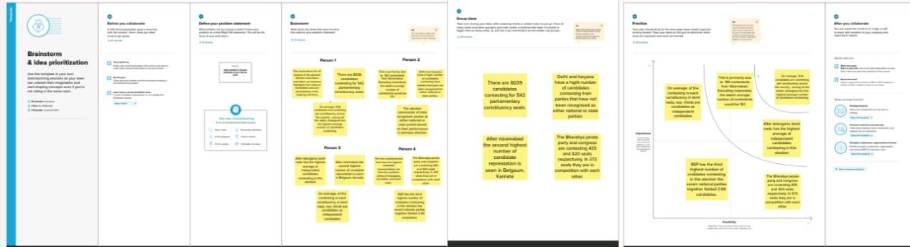

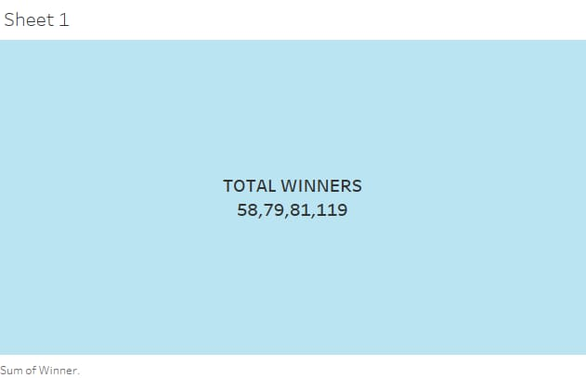**3.Result**

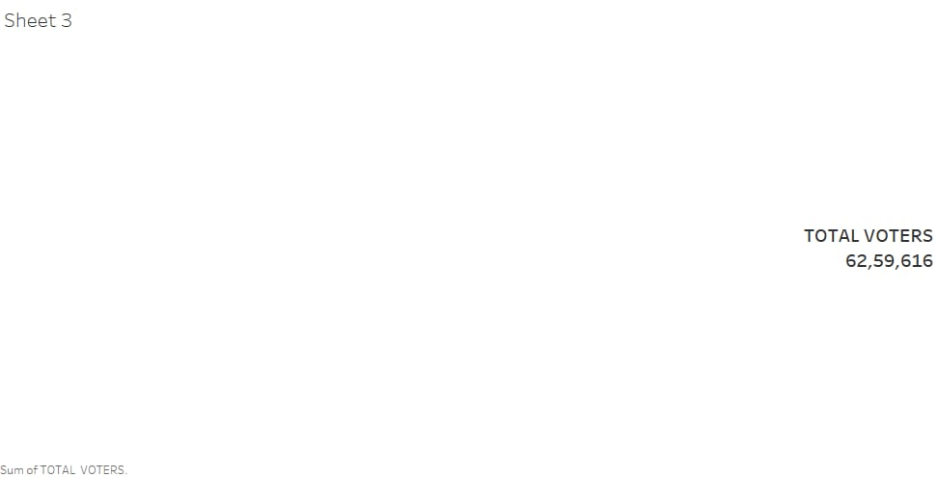

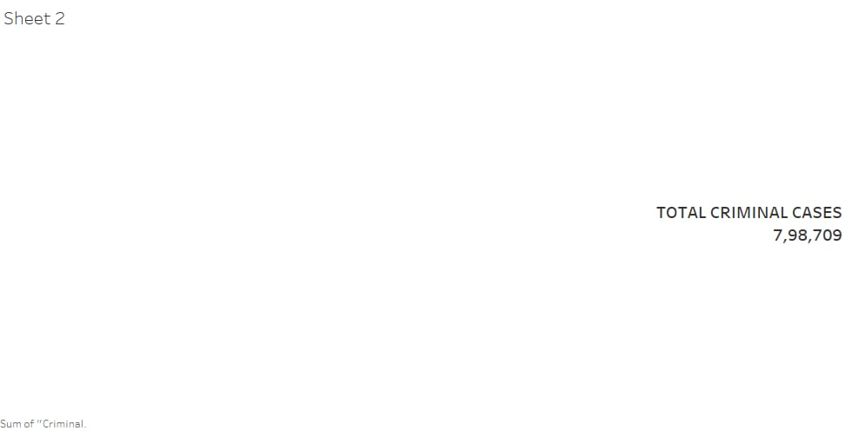

IMG-20231024-WA0006

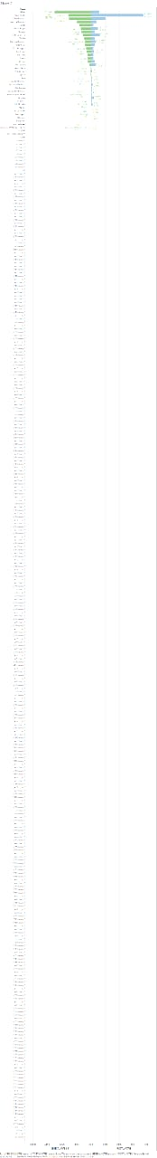

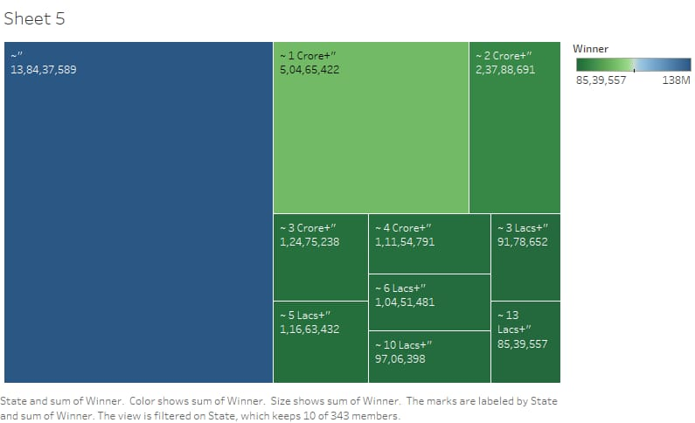



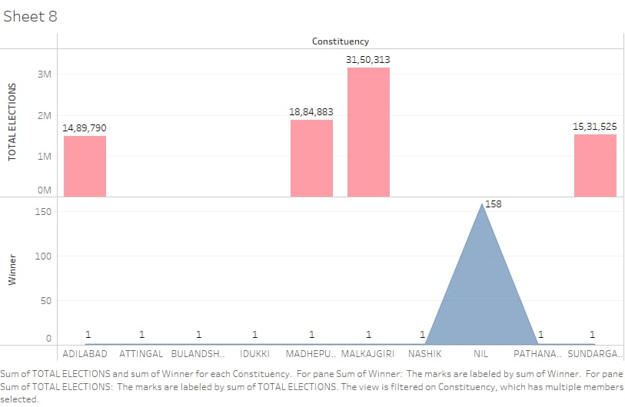

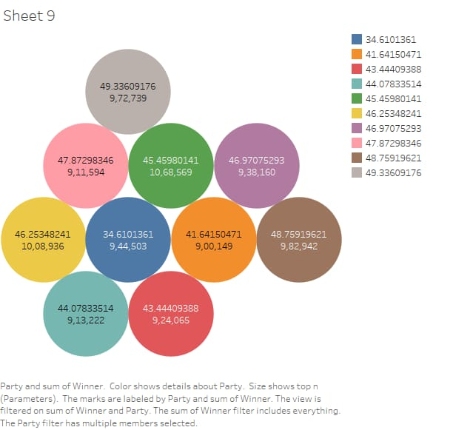

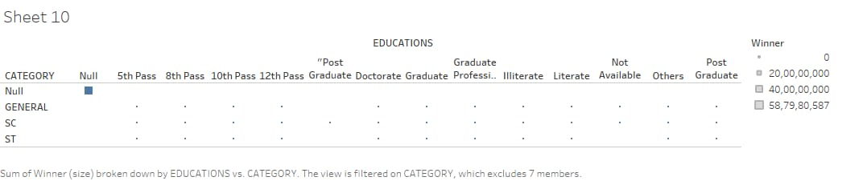

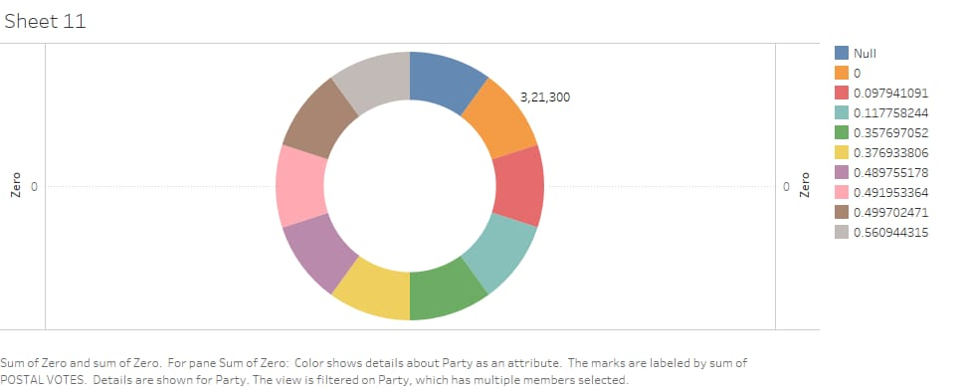

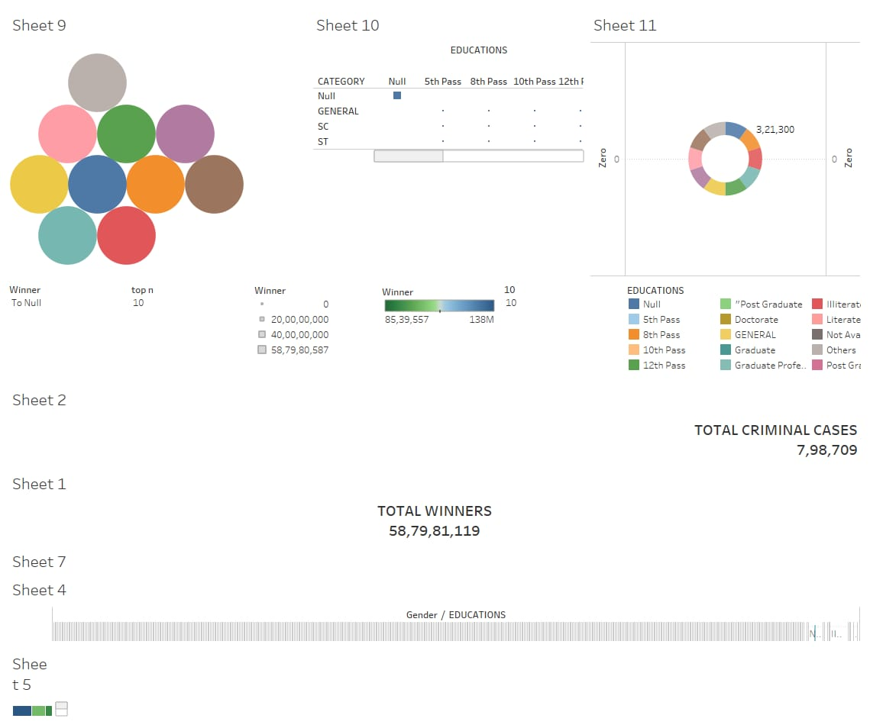

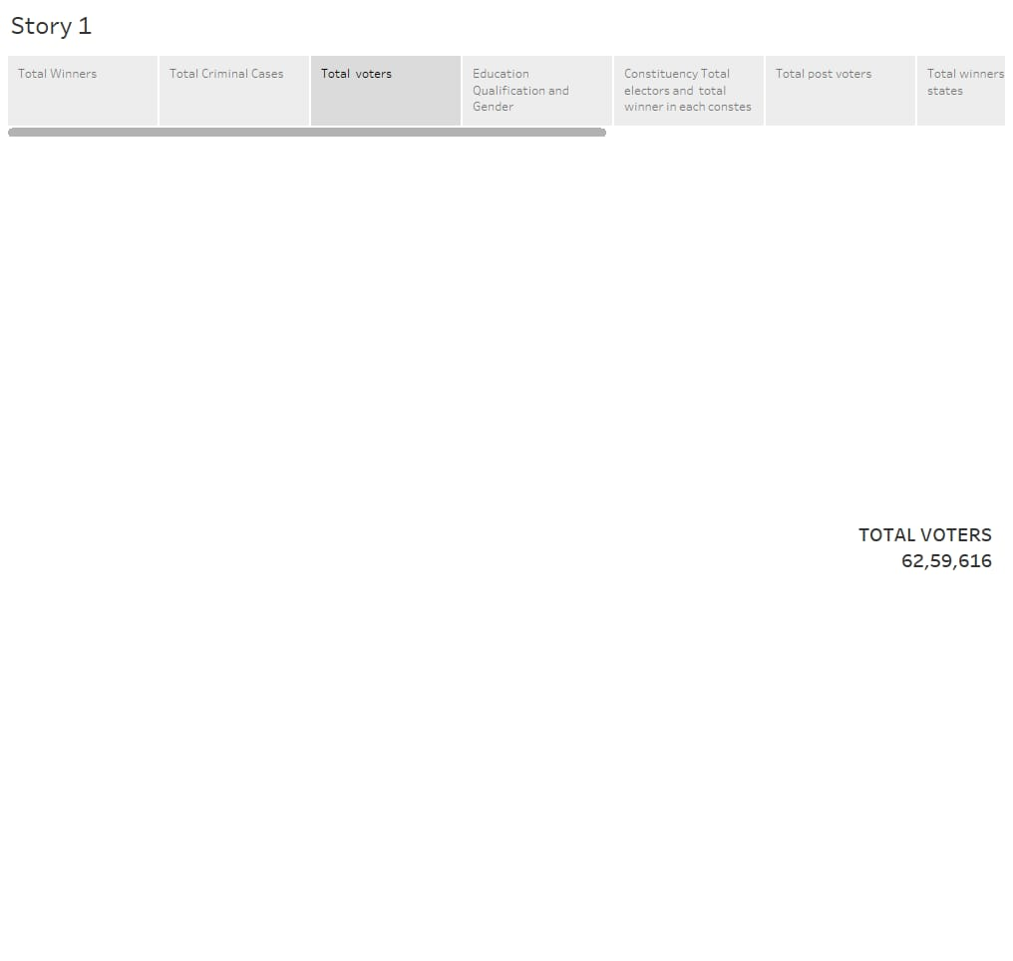

**4. Advantages** **and Disadvantages**

**Advantages**

       Voters can make more information choices based on a better understanding of candidates profiles and qualifications

         The analysis can help in revealing important about candidates such as criminal records

           The project can lead to data driven policy recommend actions aimed at improving the representation of underrated group and addressing issues in candidates selection

**Disadvantages**

      The date can be misused for political purposes such as selective reporting of finding to support a particular aqenda

          The publication of candidates personal information such as criminal records May raise privacy concerns and ethical considerations should be taken into account

**Applications**

      Serving as a valuable resource for researchers and scholars interested in the field of political science, sociology and public policy

         Providing date and insights for journalists to report on election dynamics, candidate profiles and political trends

**Conclusion**

    In our comprehensive analysis of the candidates in the 2019 Lok sabha elections,we embarked on a journey to uncavel the intricacies of the democracy

Our aim was to provide a quantitative examination of the individuals who participated in this pivot democratic exercise, shedding light on variously aspects of the political landscape

**THANK YOU**